Use graphical methods to solve the linear programming problem.
1) Maximize z = 6x + 7y
Subject to:

2x + 3y ≤ 12
2x + y ≤ 8
x ≥ 0, y ≥ 0

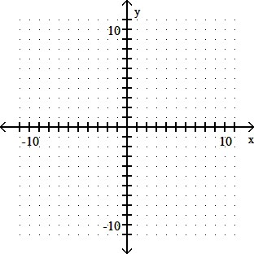

$$Type equation here.$$

Use the Venn diagram to find the requested set.

2) Find A ∩ B.
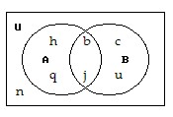

Let U = {q, r, s, t, u, v, w, x, y, z}
A = {q, s, u, w, y}
B = {q, s, y, z}
C = {v, w, x, y, z}

Determine the following.
3) (A' ∪ C) ∩ B'

Use a Venn Diagram and the given information to determine the number of elements in the indicated region.

4) At Southern States University (SSU) there are 399 students taking Finite Mathematics or Statistics. 238 are taking Finite Mathematics, 184 are taking Statistics, and 23 are taking both Finite Mathematics and Statistics. How many are taking Finite Mathematics but not Statistics?

Evaluate the expression.

7) (9 C 4)/ (9 C 3)

Solve the problem.

8) License plates are made using 2 letters followed by 2 digits. How many plates can be made if repetition of letters and digits is allowed?

Solve the problem.

9) If the police have 9 suspects, how many different ways can they select 5 for a lineup?

Solve the problem.

10) In a Power Ball lottery, 5 numbers between 1 and 12 inclusive are drawn. These are the winning numbers. How many different selections are possible? Assume that the order in which the numbers are drawn is not important.

